**Composite Cryogenic Fuel Tank**

Portland State University

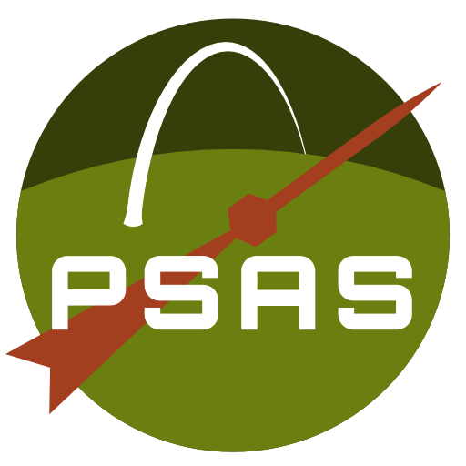

Team Lead

Alex Farias

Undergraduate Student, Department of Mechanical and Materials Engineering

Portland State University

1323 SE 65th Ave. Hillsboro, OR 97123

(971)770-6017

afarias@pdx.edu

Project Advisor

Jun Jiao

Department of Mechanical and Materials Engineering

Portland State University

(503) 725-4228

jiaoj@pdx.edu

**Date of Submission: 2017-01-16**

**Project Description**

Our research will study the feasibility of a composite, cryogenic fuel and oxidizing tank for the Portland State Aerospace Society (PSAS) high altitude amateur rockets (LV3 and LV4). This research will also function as a senior capstone project to meet undergraduate graduation requirements in the Portland State University Department of Mechanical and Materials Engineering.

The rocket will use liquid oxygen (LOX) and ethanol as a propellant. Therefore, the tank must withstand cryogenic temperatures. Various liner and insulation materials will be tested to prevent leaking and reduce thermal stress. We will use FE modeling and destructive testing to validate our tank design.

In developing a composite tank we need to answer four questions: what is the geometry of the tank design, what materials are appropriate, how should the vessel be manufactured, and what are the operating parameters of the final tank design.

**Tank Geometry**

Our research will focus on developing a multi-layer composite fuel tank geometry that can accommodate fuel and electrical feed lines within the pre-existing LV3 airframe module design or, alternatively, substituting an entire airframe module with an independent fuel module. However, the primary goal of our project is not necessarily a fully flyable fuel tank, but initial feasibility testing and analysis.

**Manufacturing Processes**

We will use hand layup techniques pioneered by the PSAS carbon fiber airframe design (LV3) to manufacture composite layers for the cryotank. We will create a laminate skirt similar to the one used in the NASA Composite Cryotank Technologies and Demonstration (CCTD) Project[1] to allow the tank to mate with adjacent components and provide structural support for external loading.

To apply composite material in the desired tank geometry, aluminum rings are attached to a cylindrical mold with spherical ends. Plain weave carbon fiber, structural adhesive, and Nomex honeycomb are placed on the aluminum rings using a hand layup technique. The composite is compressed onto the mold with a vacuum bag and the module is placed in an oven to cure the epoxy. This layering technique and corresponding ring design are expected to be modified according to addition of materials, changes in layering methods, and tank geometry requirements.

**Material Selection**

Materials are selected based on their compatibility with LOX which has a boiling temperature of -182.9ºC at 1 atm and is a powerful oxidizer. Current layering materials under consideration include carbon fiber composite (structural material), PTFE (chemical insulator), and Cryogel (thermal insulator). To prevent liquid oxygen from leaking into the composite layers, a Teflon (PTFE) liner is desirable due to its excellent mechanical and thermal properties at cryogenic temperatures. The optimal composite liner will be determined by comparing a spray on coating of PTFE resin wetting agent with a liner made of PTFE resin granular molding powders that is compression molded to the tank geometry and sintered. An insulation layer such as spray on foam, aerogel, and cryogel are considered to create a thermal barrier between the LOX and the composite layers. These materials are preliminary test materials and subject to change based on the results of further research and testing.

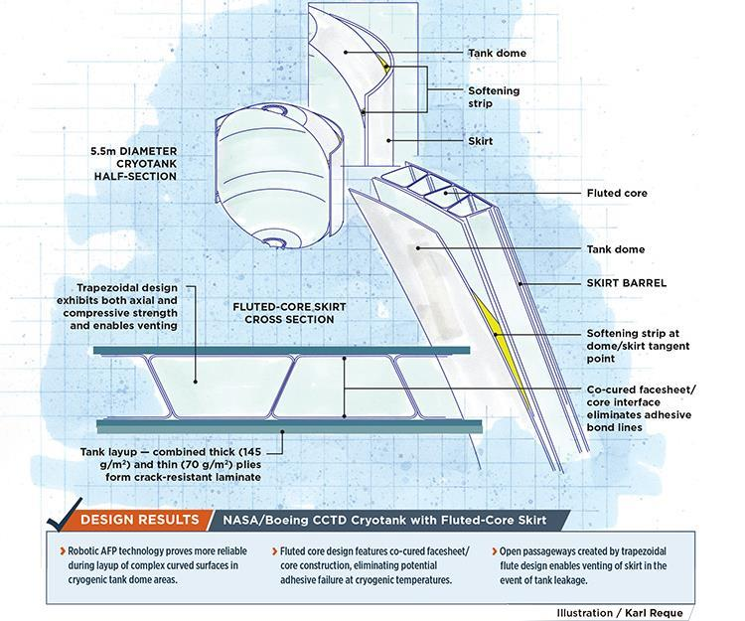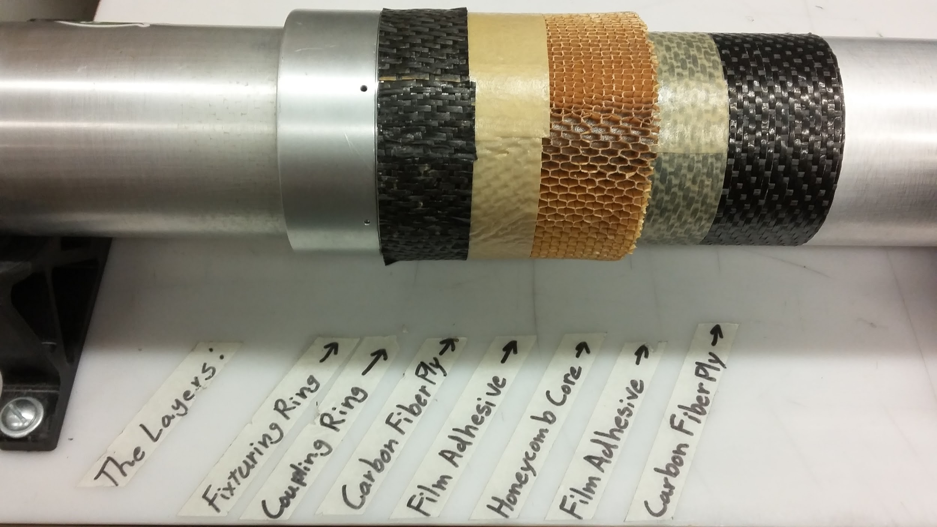

|  |  |
| --- | --- |
| *Figure 1: NASA/Boeing CCTD Cryotank with Fluted-Core Skirt. Illustration: Karl Reque* | *Figure 2: 2015-2016 Composite PSAS airframe layer configuration* |

**Testing**

We will conduct hydrostatic testing on the prototype to determine the maximum allowable working pressure (MAWP) of the tank. According to ASME, section VIII, Pressure Tests, MAWP = Minimum Hydrostatic Test Pressure/(1.3*LSR), where LSR is the lowest stress ratio of the allowable stress at test temperature to the allowable stress at design temperatures. Microfracture and material degradation analysis will be performed on cryogenically-treated sample composite coupons using microscopy equipment available in the Center for Electron Microscopy and Nanofabrication.

We will perform a thermal fluid analysis of the fill and drain operation to gain an understanding of the thermal stress the tank will encounter at the composite-aluminum and composite-layer interfaces. The cryogenic test will consist of filling the tank with liquid nitrogen, waiting for steady-state conditions, and draining the tank. Sensors will be used to measure the temperature, pressure, strain, and heat flux during testing.

*Table 1:* ***Key Milestones and Deliverables*** *(01/09/17 - 06/12/17)*

|  |  |
| --- | --- |
| Week 1-3 | Select insulation material and polymers based upon cost and material properties.  Devise and test polymer deposition techniques with refined selection of materials. |
| Week 4-6 | Create SolidWorks design for aluminum rings and easy access fill-ports.  Perform thermal and mechanical stress/strain analysis with FEA simulations. |
| Week 7-9 | Interface tank components and complete composite layup for tank prototype. |
| Week 10-12 | Perform hydrostatic tests to determine working tank pressure. |
| Week 13-15 | Perform cryogenic tests to assess aluminum ring/composite interface.  Test fill with LOX, pressurize, and test fire using PSAS 3D printed engine and liquid fuel test stand. |
| Week 16-18 | Organize and complete documentation for final report and presentation |

**Scholarly Aspects and Educational Objectives**

The composite cryogenic fuel tank project will give our team an opportunity to learn how to design parts for manufacturing, fabricate composite materials, test prototypes, and create technical documents to report procedures and results. This experience will directly support the main objective of the PSU capstone which provides students with teamwork, project management, communication, and engineering experience to prepare us for our careers following graduation. This project also provides invaluable experience attacking an open-ended problem in which the team must make design decisions without a clear list of constraints, since all design parameters are codependent within the greater PSAS LV4 Rocket Project.

**Expected Outcomes**

Amateur and University rocket teams are making huge strides to create rockets that can reach the Von Karman line (100 km), but most teams are limited by using heavy aluminum tanks. Switching from aluminum to carbon fiber material has the potential to increase rocket performance by reducing a dramatic amount of weight. If we are successful, LV4 can carry larger payloads and give the academic community an opportunity to do research in suborbital space. Since PSAS is open source, our research will also provide further insight on composite cryogenic propellent tanks and will pave a path for future composite tank designs.

**Synergy**

**Team-Advisor Collaborative Learning**

The composite cryogenic fuel tank project is essentially a recursive design problem-- What combination of geometry and material produces a structurally and chemically sound LOX fuel tank? This question presents a number of research, design, and testing challenges that require both mechanical and material engineering solutions. This team’s experiential background is primarily mechanical; our project advisor, Dr. Jun Jiao, is an experienced materials engineer. This combination encourages our team to take full advantage of the team-advisor relationship to learn about proper manufacturing and testing processes (and how to make informed selections of structural and insulative materials) as we test various geometries and layering techniques.

Additionally, Dr. Jiao’s position, as Director of the Center for Electron Microscopy and Nanofabrication, makes various material testing equipment and resources (including a cryogenic probe station) available to our team-- resources that would not otherwise be easily accessible to an undergraduate research team. Dr. Jiao has also served as a conduit to industry donors for past PSAS capstone teams, helping them get access to proprietary materials such as the Boeing carbon fiber sheets that serve as the basis for the current PSAS composite airframe. As the PSAS rockets’ design requirements increasingly require the development of custom build materials, we hope to develop and reinforce the relationship between PSAS and the Material Science department through our collaboration with Dr. Jiao on this project.

**Leveraging Opportunities for Funding or Further Research**

Regardless of the outcome, the results of this project’s research will have implications for other PSAS projects. Knowing whether or not a composite cryogenic fuel tank is feasible given the resources we have access to, and knowing its limitations, will inform how all future rocket airframes are designed and built. For example, if a composite LOX fuel tank is viable, but only at relatively low pressures, then that provides constraint parameters for the PSAS Electric Feed System capstone team, which is attempting to substitute the current, heavier pressure-fed system that relies on highly pressurized fuel tanks. If we determine that a composite tank could function at higher pressures, or the electronic feed system cannot work within the constraints provided by the fuel tank design, then the incentive becomes to refine the pre-existing feed system.

If PSAS can reduce the dry weight of the rocket by integrating a composite cryogenic fuel tank and/or an electronic propellant feed system, then building a small-scale rocket that will reach the Von Karman line becomes feasible and launching a nano-satellite (PSAS’ ongoing CubeSat project) into low-earth-orbit becomes a viable target goal for a university aeronautics team. This is a novel realm for university-level rocketry : to our knowledge, no university club has successfully flown a rocket beyond the Von Karman line. Such a flight would likely generate public and academic interest that could be leveraged for further funding and support from a range of institutions, organizations, and private donors.

This project also fulfills the requirements of a senior mechanical engineering design capstone project for the 6 primary members of the team and will provide the opportunity to develop general engineering and aerospace-specific skills in the subject areas of design, structural and thermal analysis, material science, and manufacturing.

The goal of this project is not just to advance the knowledge and resources of PSAS and its teams, but to methodically document and share this project’s findings and make them available to the public. This serves to educate and encourage other academic groups to advance their rocketry research and development. Contributing to the growth and wealth of research in this field is always an underlying goal.

**Aerospace Relevancy**

The NASA Space Technology Mission Directorate’s Game Changing Development (GCD) Program supports the CCTD project, where NASA and Boeing engineers aim to improve composite cryogenic tank technology for heavy lift vehicles and other in-space applications. Success in the CCTD project could lead to rocket fuel tanks that are more than 30 percent lighter and offer lower cost for payload delivery to orbit[2].

If the composite cryogenic fuel tank research is successful, our tank design has the potential to make the LV3/LV4 rocket fuel tanks significantly lighter than their aluminum counterparts, which would allow PSAS to carry larger payloads, such as a cubesat, to lower Earth orbit.

Similar to NASA’s Human Exploration and Operations Launch Services Program, PSAS could provide lower earth orbit research opportunities to the academic community. Further development in composite cryotank technology will lead to more cost effective space travel, not only for professional ventures involving larger firms such as NASA, but additionally for university or amatuer venture launches.

**Budget**

This budget includes materials and services necessary to prototype our composite fuel tanks. It also includes previous and future in-kind and services donations.

|  |  |  |  |  |
| --- | --- | --- | --- | --- |
| **Item** | **Description** | **Vendor** | **Amount** | **Matching** |
| 6061 Aluminum | Material for rings and mold | Metal Supermarket | $800 |  |
| Machinable Foam | Material for composite mold | Sailrite | $200 |  |
| Liquid Nitrogen | 40 gallons of liquid nitrogen for fill and drain cryogenic testing | PSU Chemistry Stockroom | $140 |  |
| Liquid Nitrogen Handling | Protection equipment | PSU Chemistry Stockroom | $100 |  |
| Liquid Oxygen | 40 gallons of liquid oxygen for cryogenic test | Airgas | $200 |  |
| Aluminum Foil | 1000 sq ft. insulation material | Uline | $43 |  |
| Cryogel Z | 30 sq ft. insulation material | Aspen | $900 |  |
| PTFE | Molding powder, and resin wetting agent for tank liner | Chemours | $1,800 |  |
| Plain Weave Carbon Fiber Prepreg | Composite material | Pacific Coast Composites |  | $3,500 |
| Nomex Honeycomb | Core material for composite | Pacific Coast Composites |  | $2,000 |
| Meltbond | 3M composite structural adhesive | Pacific Coast Composites |  | $2,500 |
| Aluminum mating rings | Material and machining for manufacturing mating rings (12 rings) | Machine Sciences |  | $3,600 |
| Layup Mandrel | Mold for composite layup | Arrow |  | $350 |
| Aluminum dummy layup rings | Mold assembly part | PSU Melt |  | $180 |
| Mechanical Components | Seals, gaskets, plumbing fittings | Various Vendors | $1,000 |  |
| Sensors and Gauges | Sensors and gauges for cryogenic testing | HBM | $1,500 |  |
| Discretionary Machining Labor |  |  | $2,000 |  |
| Sandpaper | Sandpaper of varying grit | Home depot |  | $50 |
| Vacuum Bagging Material | Vacuum bags, Breather fabric, sealant tape, and release film | Fiberlay |  | $770 |
| Vacuum Pump Equipment | Pump regulator, pump oil, reducer adapter, hose |  |  | $180 |
| Orca Seal | Solvent for mold surface treatment | Fiberlay |  | $130 |
| Orca Clean | Solvent for mold surface treatment | Fiberlay |  | $100 |
| Compression molding material | Shrink tape, kapton tape, industrial scissors, ceramical | Various Vendors |  | $230 |
| Heat gun | Heat gun for composite layup | Milwaukee | $180 |  |
| Dr. Jun Jiao's Time | 1 hour per week, Jan - Jun (20 weeks) at $100/hr |  |  | $2,000 |
| Future Material Donations | Future material donations from Boeing, Pacific Coast Composites |  |  | $6,000 |
| Future Services Donations | Material and machining time from Machine Sciences Corporation |  |  | $3,000 |
| **Total** |  |  | **$8,863** | **$24,590** |

**Team Lead Resume**

**Alex K. Farias**

1323 SE 65th Avenue, Hillsboro, OR 97123

(971) 770.6017 ~ afarias@pdx.edu

**EDUCATION**

**Bachelor of Science in Mechanical Engineering** (09/14/2015 – 06/21/2017)

*Portland State University, Portland, OR*

**COURSE HIGHLIGHTS**

Heat Transfer, SolidWorks, Fluid Mechanics, Thermodynamics, Experimental Design, Finite Element Analysis, Material Science, Technical Writing, Engineering Economic Analysis

**CERTIFICATION**

· SolidWorks Associate, Certificate ID: C-UVWU2UYBK5

**SOFTWARE AND COMPUTER SKILLS**

· Working knowledge of finite element method using Abaqus

· Proficient with MS Word, Excel, and PowerPoint

· Proficient with MATLAB and R data analysis software

· Familiar with C++ programming language

**EXPERIENCE**

**Student Member** (01/2016 –Present)

*Portland State Aerospace Society, Portland, OR*

· Designed rocket part assemblies and technical drawings using SolidWorks

· Machined aluminum rocket parts using mill and lathes

· Fabricated composite rocket airframe using hand layup and compression molding techniques

**PSU Student Chapter Team Member**, (01/2016 –07/2016)

*Engineers without Borders, Portland, OR*

· Analyzed design options for sustainable hand washing station at developing Ethiopian school

· Prepared alternative analysis report to validate hand washing station design

**Office Assistant** (03/2015 – Present)

*Portland Community College Jobs & Internships Department, Portland, OR*

· Performed research to assist with project development

· Evaluated course curriculum and provided recommendations to fix issues

· Coordinated logistics with business partners participating in campus events

· Evaluated department statistics to optimize resources

· Organized department records and processed confidential documents

· Created presentations used for student development

**Assistant Manager** (06/2012 - 12/2015)

*Portland Community College Bookstore, Portland, OR*

· Responsible for overseeing day-to-day store operations

· Managed group projects and reported progress to supervisors

· Provided training, support, and guidance in team oriented environment

· Coordinated shipping and receiving to ensure on-time delivery for high volume orders

**Portland Community College STEM Club Volunteer** (09/2014 & 09/2015)

*OMSI Maker Faire, Portland, OR*

· Trained volunteer members to use CNC machines and software

· Demonstrated CNC and Laser Cutting technology to community members

**Team Member Listing and Experience Profiles**

Group Demographics:

Male/Female Students: 5/1

Underrepresented minorities: 2 Hispanic students

Neil Benkelman: (Mechanical Engineering Undergraduate, PSU)

Past project experience developing autonomous navigation and hazard avoidance platform for use with a drone, fluid dynamics, heat transfer, FEA, data analysis software (R and MATLAB), machine shop access.

Russell Berger (Mechanical Engineering Undergraduate, PSU)

Experience with manufacturing composite airframe parts for Atomic Aviation, advanced fluid mechanics, phase transformation and kinetics of materials, SolidWorks, and owns a 3D printer. Experience with data analysis software (R & Matlab), as well as CAM software for CNC machining, and machining with emphasis on lathe.

Alex Farias (Mechanical Engineering Undergraduate, PSU)

Experience with SolidWorks, manufacturing composite airframe for PSAS rocket, FEA, advanced fluid mechanics, data analysis software (R and Matlab), and machining with lathes and mills.

Francesca Frattaroli: (Mechanical Engineering Masters Pathway Undergraduate, PSU)

Biogeochemistry lab and field technician. Experience in designing and prototyping low‐cost sensor apparati for environmental research, data analysis software (R and Matlab), FEA, Advanced Fluid Mechanics and machine shop experience (mills and saws).

Weldon Peterson: (Mechanical Engineering Undergraduate, PSU)

Experience with lathe and milling processes, Solidworks, machining design, geometric dimensioning and tolerancing, data analysis software (R and Matlab). Also previously experience with liquid oxygen as a fuel in glass studio and great group dynamic with the rest of the team.

Christopher Wilson: (Mechanical Engineering Undergraduate, PSU)

PSAS member, Experience with geometric dimensioning and tolerancing, controls, laser cutters and 3d printers, machine shop access with minor experience on the mill and lathe, data analysis software (R and Matlab).

1. <https://ntrs.nasa.gov/archive/nasa/casi.ntrs.nasa.gov/20130013009.pdf>

   Structures and Design Phase I Summary For the NASA Composite Cryotank Technology Demonstration Project. 2013
2. <https://gameon.nasa.gov/projects-2/archived-projects-2/composite-cryogenic-propellant-tank/>

   Composite Cryotank Technologies and Demonstration (CCTD)